**Ideation Phase**

**Brainstorm & Idea Prioritization Template**

|  |  |
| --- | --- |
| DATE | 29 OCT 2022 |
| TEAM ID | PNT2022TMID34509 |
| PROJECT NAME | **Predicting the energy output of wind turbine based on weather condition** |
| MARK | 4 MARK |

**Step-1: Team Gathering, Collaboration and Select the Problem Statement**

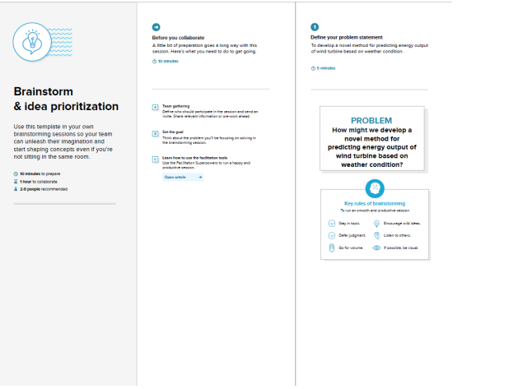

**Step-2: Brainstorm, Idea Listing and Grouping**

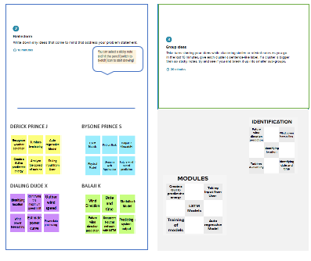

**Step-3: Idea Prioritization**

